Software Development Unit 3, 4.5

Anna Legaspi

# I can archive the outcome of collaborative working

## Github

Within Github, there is a facility to save version controls of my coursework. By utilising Github Desktop, I can simply sync the relevant folders with Github and it will keep track of any changes and I can update this and create a newer version whenever necessary.

Under **Current repository/Changes**, any updates I’ve made on any existing files will appear. If I commit this main and update it, it will update the older version online with the most recent version.

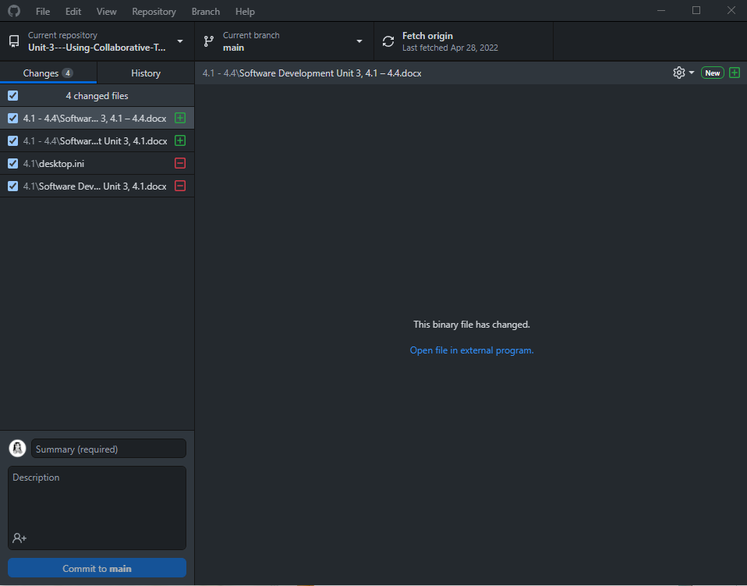

Under **Current repository/History**, you can find all the updates and versions I’ve made. They’re all labelled ‘update’, but the date when the update is shown is also noted. If I click each date, it will show all the files as they were at that time, which is a form of version control.

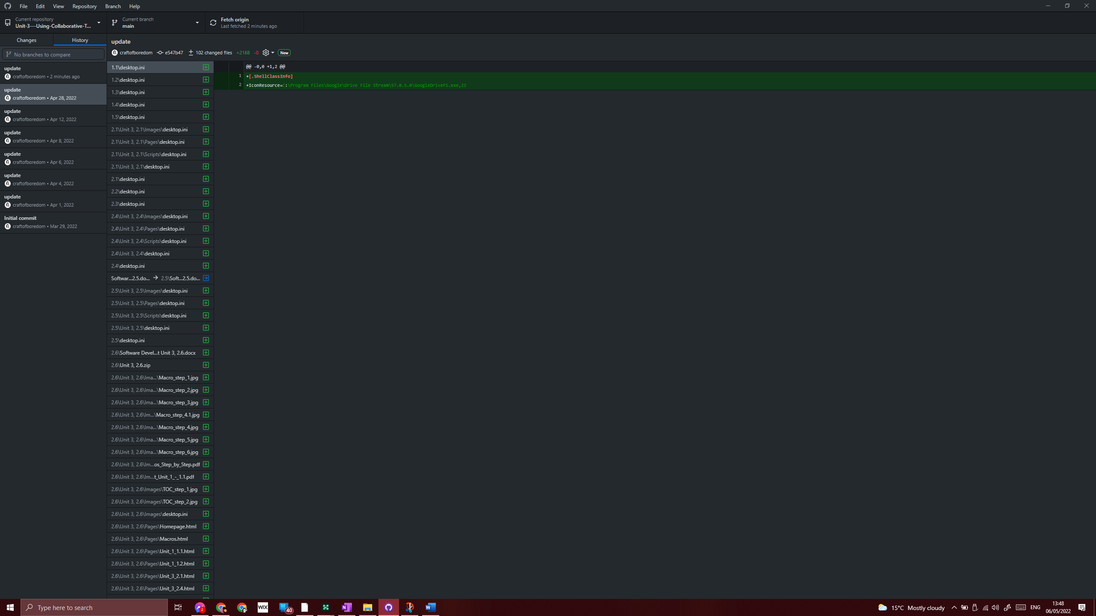

## Zip files

I am also able to Zip up files for archiving if needed. For example, I currently have digitally scanned files that I no longer need to access at all times. To save space in my hard drive, I can zip these files. For example, I can archive all these files from a previous unit into one zip file.The zipped file can be unzipped in the future.

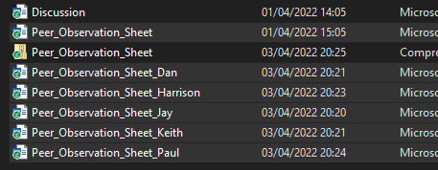

To zip a file, I simply need to highlight all the files that need to go into the zip file. I can do this by highlighting with my mouse or by using keyboard shortcuts such as ***Ctrl + A, Shift + right click, Shift + right click.***

